
Software Engineering Department
Braude College of Engineering
Final Project – Phase B (61999)


UniSched – University Course Timetabling System
Code: 26-1-D-13
By:
Gal Moyal
Eden Furman

Advisors:
Dr. Julia Sheidin
Dr. Avital Shulner Tal

Link to GitHub:
https://github.com/GalMoyal111/course-scheduling-system.git
Table of contents
Abstract 3
1. Problem Overview and Background 4
2. General Description 5
3. Development Process & Planning 6
4. System Architecture & Solution Description 8
5. Challenges and Solutions 17
6. Results and Conclusions 19
7. Succes Metric 20
8. Lessons Learned 21
9. AI Tools and Prompts Used 22
10. References 23
11. Appendixes 24
11.1. User guide - Course Scheduling System 24
11.2. Maintenance manual 36

Abstract
This project presents an automated course timetabling system developed for the Software Engineering Department at Braude College. Replacing inefficient manual processes, the system utilizes a custom Constraint Satisfaction Problem (CSP) algorithm to strictly enforce logistical hard constraints while optimizing dynamically weighted soft constraints, such as lecturer preferences. Built as a full-stack solution with Java Spring Boot, React, and Firebase, the system enables rapid timetable generation, Excel data integration, and manual adjustments, significantly improving the department's operational efficiency.
Keywords: scheduling, optimization, algorithm, constraint programming.

1. Problem Overview and Background
Creating an academic timetable is one of the most important and complex tasks in colleges and universities. It is a difficult scheduling problem because many courses, lecturers, student groups, classrooms, and time slots must be arranged together while following many constraints.
In the Software Engineering Department at Braude College, the timetable is currently created manually by Ora, the assistant head of the department. During this process, she must consider lecturer availability, classroom capacity, room types, course requirements, and different lesson types such as lectures, tutorials, and labs. Since this work is done manually, the process is slow, complicated, and difficult to update when changes are needed.
The literature review shows that academic timetabling is known as the University Course Timetabling Problem (UCTTP). This problem is considered NP-hard, which means that as the number of courses, lecturers, rooms, and constraints increases, it becomes much harder to find a good solution in a reasonable time. The literature also shows that there is no single universal solution that fits all academic institutions, because each institution has its own rules, structure, resources, and constraints.[1],[2],[7]
Several approaches have been suggested for solving academic timetabling problems. These include Graph Coloring, Operations Research methods, meta-heuristic algorithms such as Tabu Search and Simulated Annealing, Genetic Algorithms, hybrid approaches, and CSP-based methods. Each approach has advantages and disadvantages. Some methods are useful for improving the quality of a solution, while others are better for making sure that all important constraints are satisfied.[2]
In this project, we chose to use a Constraint Satisfaction Problem (CSP) approach because the main goal is to create a valid timetable that satisfies all hard constraints. In this model, each lesson is represented as a variable that needs to be assigned a day, a time, and a room. Each variable has a domain of possible assignments, and the algorithm searches for a valid solution while checking the constraints.
The hard constraints include rules that must always be satisfied, such as preventing lecturer overlaps, preventing room overlaps, matching the room type to the lesson type, checking classroom capacity, and considering lecturer availability. The soft constraints are used to improve the quality of the timetable. For example, the system tries to reduce gaps in lecturers’ schedules, prefer better teaching hours, and use classrooms efficiently.
Therefore, the purpose of this project is to provide an automatic scheduling solution that reduces the manual workload, improves the consistency of the timetable, and helps the department create valid and practical timetables in a faster and more organized way.

2. General Description
The developed system is a web-based application designed for academic course timetabling in the Software Engineering Department at Braude .Its primary objective is to automatically generate a complete timetable for a selected semester, including the assignment of lecturers, classrooms, and time slots while considering academic, logistical, and operational constraints.
At the core of the system stands an automated scheduling engine responsible for generating valid academic timetables. The algorithmic details and scheduling model are presented in Chapter 4.
Beyond timetable generation, the system also provides supporting data-management capabilities, including management of courses, lecturers, classrooms, constraints, and scheduling settings. Users can configure system parameters, import and export data through Excel files, and manage scheduling information through a web interface.
The primary target audience of the system is the Software Engineering Department’s administrative staff, particularly Ora, assistant head of Department responsible for creating departmental timetables. The system supports two user roles: (1) regular user and (2) administrator, where administrator users have additional permissions related to user management.
Compared to the current manual workflow, the system enables automated timetable generation within minutes and allows rapid adaptation to changes in constraints, requirements, or input data through repeated executions of the scheduling process.

3. Development Process & Planning
After defining the system’s objectives and overall architecture, the practical implementation phase focused on translating the conceptual solution into a robust software system. This involved establishing a clear methodology, maintaining continuous interaction with the client, and following an iterative development lifecycle.

3.1. Requirement Analysis and Constraint Elicitation
The development process began with a thorough analysis of the course timetabling problem and the existing manual scheduling workflow. To ensure a smooth transition for the end-users, the system’s input models and data structures were designed to closely resemble the familiar formats and files already utilized by the department.
Following this initial analysis, a comprehensive constraint elicitation process was conducted. A preliminary constraint model was formulated based on academic logic, existing departmental timetables, and prior familiarity with the academic environment. Based on academic requirements and findings from the literature review, the problem was modeled as a CSP.

3.2. Iterative Development Methodology
The software implementation followed an incremental, iterative approach. The initial phase focused on building the foundational client-server communication and basic data-management modules (such as the Lessons and Courses screens), enabling early data entry and system testing.
The CSP scheduling engine was developed gradually in controlled steps. We began by implementing a core search framework based on Backtracking and Forward Checking algorithms. Hard constraints were then introduced and tested incrementally, one by one. After stabilizing the hard constraints and ensuring the algorithm generated valid schedules, soft constraints and the cost function were carefully integrated. This step-by-step methodology facilitated easier debugging, prevented logic conflicts, and allowed for continuous refinement of the timetable’s quality.

3.3. Client Interaction and Feedback Integration
Interaction with the client, specifically Ora, the assistant head of the Department responsible for scheduling, was a central component of our process. Client engagement was not limited to the initial requirements gathering but continued throughout the entire development cycle via meetings, system demonstrations, and feedback loops.
This ongoing communication significantly shaped the final product. Early testing by the client revealed necessary real-world adaptations that were not immediately obvious from a purely algorithmic perspective. As a result of this feedback, new features and constraints were introduced, such as support for English courses (with specific time preferences), handling of virtual lessons, dynamic configuration of blocked time slots, and the ability to lock manual assignments. This collaborative approach ensured the final system was not merely a theoretical scheduling engine, but a practical and efficient administrative tool directly tailored to the department's operational environment.

3.4. Tools and Technologies
To support the web-based client-server architecture, a modern technology stack was selected:
- Backend: Developed in Java using the Spring Boot framework, chosen for its robustness in handling complex business logic and the CSP engine.
- Frontend: Built with React and CSS, providing a dynamic, responsive, and intuitive user interface.
- Database: Firebase Firestore was utilized for persistent data management, offering an accessible cloud-based solution.
- Authentication: Firebase Authentication is utilized for secure user management and handling email-based password recovery.
- Deployment & Development: The system is deployed via Render (Backend) and Vercel (Frontend). Development and version control were managed using VS Code, Eclipse, and Git/GitHub.
- Design & Assistance: Figma and Visual Paradigm were used for UI/UX design and architectural diagrams. Additionally, AI tools (ChatGPT, Gemini, Figma AI) assisted with troubleshooting, technical explanations, and design ideation throughout the process.

4. System Architecture & Solution Description
UniSched combines a modular system architecture with a constraint-based scheduling engine to automate timetable generation. The following sections outline the system structure, describe how data flows between components, and explain the CSP mechanisms used to construct feasible schedules.

4.1. High-Level Architectural Design
The system is built upon a modern, distributed 3-tier Client-Server architecture to ensure modularity, scalability, and separation of concerns (see Figure 1):
- Presentation Layer (Frontend): Developed using React.js, this layer provides a dynamic User Interface (UI). It handles user interactions, data validation on the client side, and visualizes the generated timetables.
- Business Logic Layer (Backend): Implemented in Java using the Spring Boot framework. This layer acts as the system's brain. It exposes RESTful APIs to the frontend, processes Excel file ingestions, manages entity constraints, and heavily executes the core CSP scheduling algorithm.
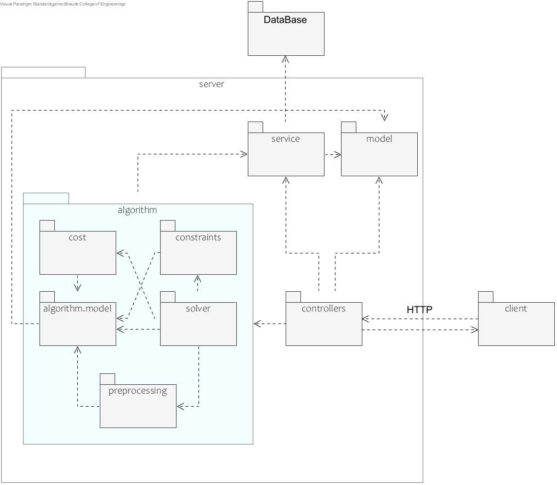
- Data Access Layer (Database): Utilizes Firebase Firestore, a cloud-based NoSQL database, to ensure persistent, real-time data storage for all system entities and historical timetables.

Figure 1: High-Level System Architecture and Package Diagram

4.2. Data Preparation Workflow and System Entities
Before a timetable can be generated, the system requires a complete and consistent set of academic and operational data. Since many entities depend on one another, UniSched enforces a predefined data-entry workflow that guides the user through the preparation process and reduces the likelihood of configuration errors.
The process begins in the Settings page, where the user defines the system-wide scheduling parameters. These include the academic clusters, the default classroom capacity, and restricted time slots in which lessons cannot be scheduled (for example, institutional breaks). These settings establish the global scheduling environment and serve as the foundation for all subsequent data entry operations.
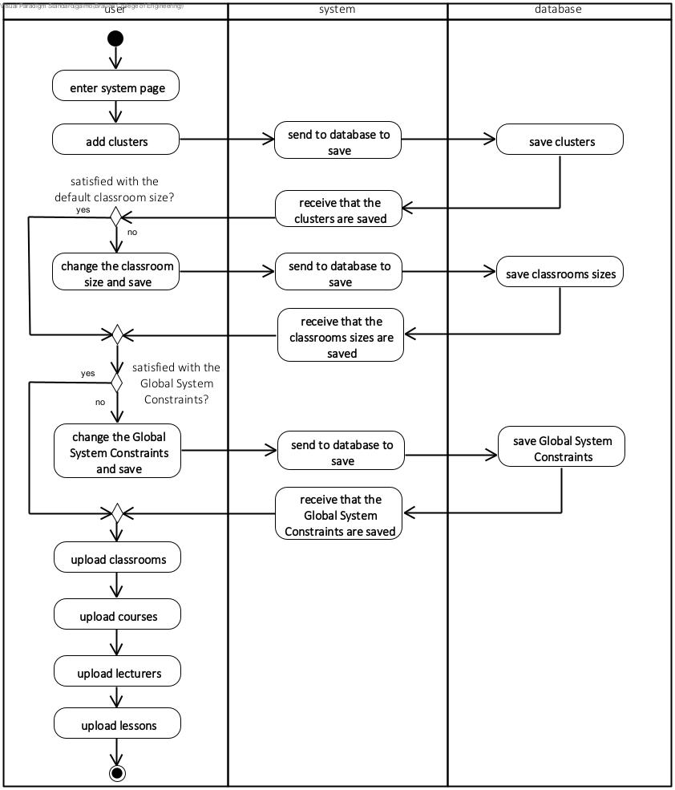
After configuring the system settings, the user proceeds through the data preparation stages in a predefined order. First, classrooms are added, followed by courses, lecturers, and finally lessons. This sequence is important because each entity depends on information defined in previous stages. For example, lessons cannot be fully defined before the corresponding courses and lecturers exist in the system. Figure 2 illustrates the complete data preparation workflow and the dependencies between the different entities.

Figure 2: Overall System Flow Activity Diagram
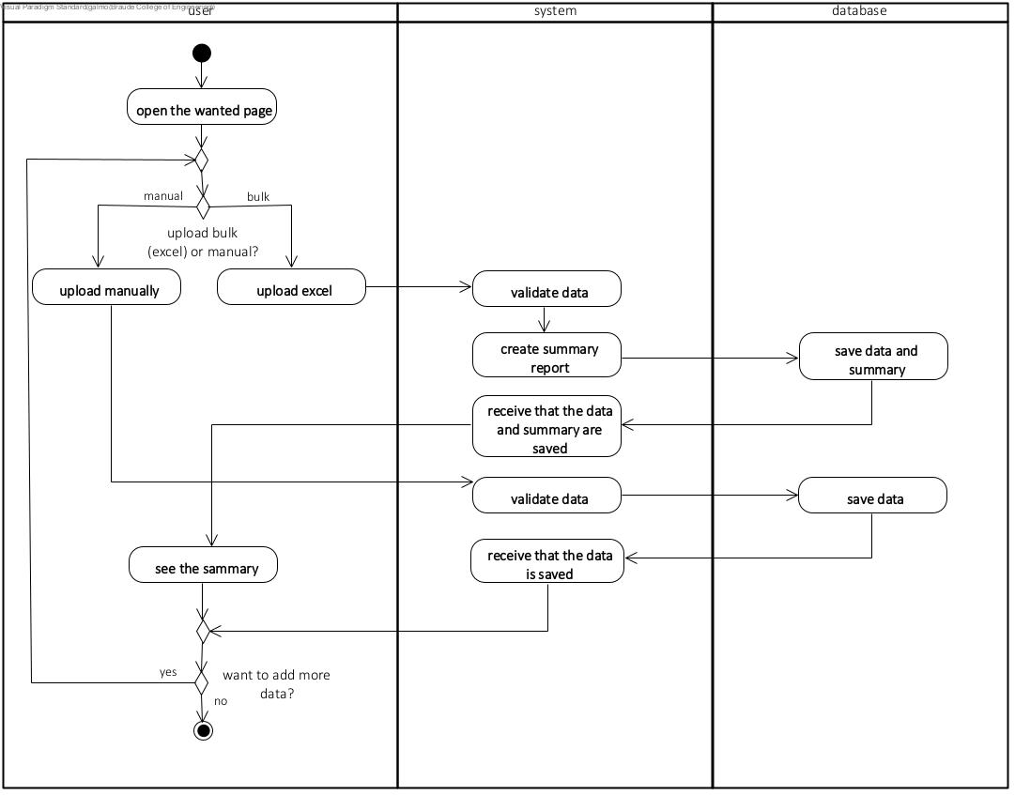
Each data-management page supports two methods of data entry: manual insertion through dedicated forms or bulk upload using Excel templates provided by the system. When an Excel file is uploaded, the system performs validation checks, processes the data, and generates a summary report indicating which records were successfully imported and which records failed validation, together with the reasons for the failure. If data is entered manually, the same validation rules are applied before the information is saved to the database. After the data is successfully stored, the user may continue adding additional records or proceed to the next preparation stage. Figure 3 presents the detailed workflow of the data ingestion process.
Figure 3: Data Entry and Upload Activity Diagram

4.3. The Algorithmic Core: CSP Mathematical Formulation
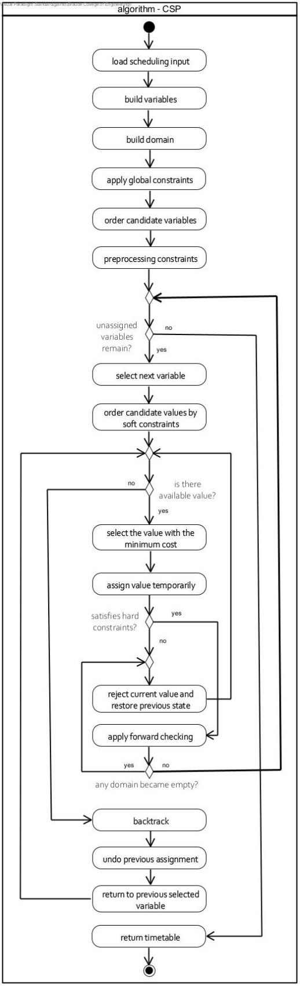
The timetable generation problem was modeled as a CSP. CSP is a mathematical framework in which a set of variables must be assigned values from predefined domains while satisfying a collection of constraints. This approach was selected because academic scheduling inherently involves many restrictions, dependencies, and optimization objectives that must be considered simultaneously.
Formally, the scheduling problem can be represented as: $[CSP=(X,D,C)]$ where:
- $(X)$ represents the set of variables.
- $(D)$ represents the domains of the variables.
- $(C)$ represents the set of constraints.
Figure 4 presents the overall workflow of the scheduling algorithm, from variable construction through domain reduction, constraint processing, and final timetable generation.

Variables
Each lesson stored in the system is transformed into a CSP variable. A variable represents a scheduling unit that must be assigned a valid time slot and classroom. The variable contains all information required by the scheduling engine, including the course identifier, lecturer, lesson type, duration, academic cluster, credit points, required classroom capacity, and additional scheduling properties.
The complete set of variables is denoted as:
$[X=\{x_1,x_2,...,x_n\}]$
where each variable $(x_i)$ represents a lesson that must be scheduled.

Domains
For every variable, the system constructs an initial domain containing all possible scheduling alternatives. Each domain value consists of a day and starting time frame:
Figure 4: CSP Algorithm Activity Diagram
$$[D_i=\{(day,startFrame)\}]$$
The initial domain includes all teaching periods defined by the institutional calendar. At this stage, every lesson may theoretically be assigned to any available time slot.
To reduce the search space before the scheduling process begins, the system applies a set of global constraints. These constraints remove time periods that are universally unavailable, such as institutional breaks and other blocked scheduling periods. This preprocessing stage significantly reduces the size of the domains and improves the efficiency of the subsequent search process.

Variable Ordering
After constructing the variables and domains, the variables are sorted according to a scheduling priority strategy. This strategy was directly derived from consultations with the client and by analyzing her current manual scheduling workflow. The objective was to emulate her human decision-making process, ensuring that the automated results closely align with the department's established, real-world schedules. The ordering process follows these priorities:
- Semester order.
- Mandatory courses before elective courses.
- Courses with a higher number of credits before courses with fewer credits.
- Within the same course, lectures are scheduled before tutorials and laboratory sessions.
This ordering strategy increases the probability of assigning the most restrictive lessons first, thereby reducing conflicts during the search process.

Constraint Processing
Following variable ordering, additional preprocessing constraints are applied to further reduce the search space. At this stage, lecturer-specific availability restrictions are enforced.
For each variable, all domain values that correspond to lecturer unavailable periods are removed from the domain. Since these assignments can never become valid solutions, eliminating them before the search begins avoids unnecessary evaluations and improves algorithm performance.
Hard Constraints
Hard constraints must always be satisfied. Any assignment violating one of these constraints is immediately rejected. The main hard constraints implemented in the system are:
- Lecturer Availability – lecturers cannot be assigned during unavailable time slots.
- Lecturer Collision – a lecturer cannot teach multiple lessons simultaneously.
- Classroom Collision – a classroom cannot host more than one lesson at the same time.
- Classroom Capacity – the assigned classroom must contain sufficient seats for all students.
- Classroom Type Compatibility – laboratories and specialized lessons must be assigned to suitable classroom types.
- First and Second Year Evening Restriction – first- and second-year courses cannot be scheduled during evening hours on Sunday.
- Elective Course Sequence – all components of an elective course must be scheduled consecutively.
- Elective Laboratory Consistency – elective courses containing laboratory sessions must be scheduled in the same laboratory classroom.
- Networking Laboratory Pairing – networking laboratory tutorials must be scheduled as consecutive sessions.
- Split Lesson Constraint – lesson segments created from lesson splitting cannot overlap.

Soft Constraints and Cost Function
Soft constraints do not invalidate a solution but affect its quality. The algorithm evaluates each candidate assignment according to the following scheduling preferences:
Course Scheduling
- Core courses in morning hours.
- Elective courses in later time slots.
- Separation between course components where possible.
- Preferred timing for English courses.
Room and Building Preferences
- Efficient classroom capacity utilization.
- Scheduling elective course components in the same room.
- Avoiding Building P whenever possible.
- Balancing campus workload across time slots.
Lecturer Preferences
- Minimizing gaps between lessons.
- Respecting lecturer non-preferred time slots.
Student Experience
- Scheduling difficult courses during morning hours.
- Reducing late-evening and Friday lessons.
- Minimizing student schedule gaps.
- Reducing potential conflicts within the same cluster.
For each candidate assignment, the penalty returned by every soft constraint is normalized according to its maximum possible value: $P_{norm }= \frac{P_{row}}{P_{max}}$
The normalized value is then multiplied by a user-defined weight:
$P_{weighted}​=W_{i}​⋅P_{max}​$
The total assignment cost is calculated as: $Cost\left(v\right)= \sum_{i=1}^{n}{W_{i}⋅P_{norm,i}}$
This approach allows different scheduling preferences to be compared fairly while enabling users to adjust their relative importance during timetable generation.

Search Strategy and Backtracking
After preprocessing and variable ordering are completed, the CSP solver begins the assignment process. For the current variable, all remaining domain values are evaluated using the cost function described above. The values are sorted according to their calculated cost, and the assignment with the lowest penalty is examined first.
When a candidate assignment satisfies all hard constraints, it is temporarily assigned and the algorithm proceeds to the next variable. If a hard constraint violation is detected, the assignment is rejected and the next candidate value is evaluated.
If no valid assignment exists for the current variable, the algorithm performs backtracking. The most recent assignment is removed, and the solver returns to the previous variable in order to explore an alternative assignment. This process continues recursively until either a complete timetable is constructed or no feasible solution can be found.
Once all variables have been successfully assigned, the resulting schedule is transformed into timetable objects and returned to the user as the final generated timetable.

4.4. Execution Flow, Pruning, and Search Space Optimization
The scheduling problem involves a large search space due to the many possible combinations of lessons, classrooms, lecturers, and time slots. To improve performance, the system applies several optimization techniques, including feasibility checks, Forward Checking, and Backtracking. In addition, manually locked lessons are treated as fixed assignments, allowing the algorithm to generate the remaining timetable around them. The complete execution flow is presented in Figure 5.
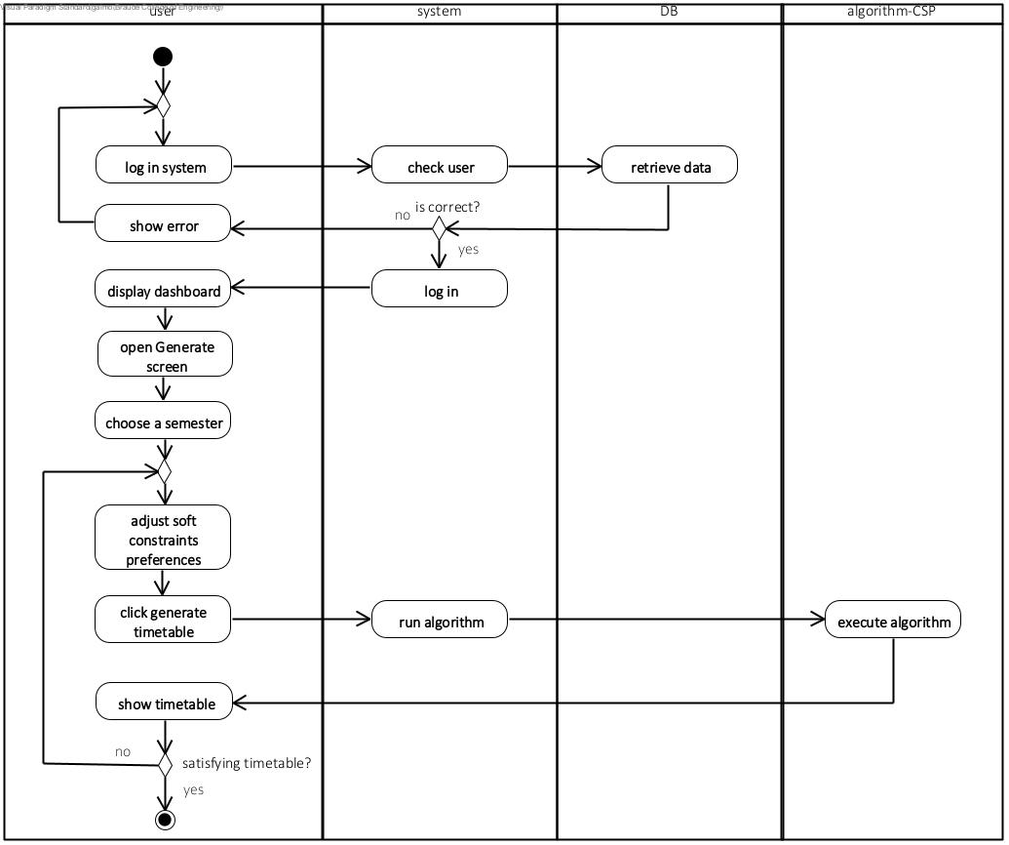
Figure 5: Timetable Generation Activity Diagram

5. Challenges and Solutions
During the development process, the project involved multiple analytical, algorithmic, and engineering challenges. Many of these challenges were not limited to technical implementation, but rather related to translating human reasoning, scheduling intuition, and practical operational considerations into formal logic that the algorithm could understand and apply.

5.1. Constraint Modeling and Algorithmic Challenges
One of the main challenges in developing the scheduling algorithm was identifying and defining the constraints required to produce a balanced, practical, and convenient timetable.
Throughout development, it became clear that many scheduling decisions that appear obvious to human users are not obvious to the algorithm at all. For example, from a human perspective, it is usually preferable to schedule lessons during morning hours or maintain a reasonable weekly distribution. However, from the algorithm’s perspective, all time slots are valid options as long as they do not violate hard constraints.
As a result, considerable effort was invested in translating these intuitive considerations into formal constraints and weighted preferences. This process required repeated experimentation, testing, and refinement in order to achieve scheduling behavior that matched real-world expectations.
In addition, the constraint model evolved continuously throughout development. Even after the model appeared complete, additional meetings with the client and evaluation of real scheduling scenarios revealed new requirements, special cases, and course-specific rules that required further adaptation of the algorithm.

5.2. Balancing Solution Quality and Practical Constraints
Another significant challenge involved balancing timetable quality with practical system limitations.
The deployed version of the system operates on relatively limited free-tier infrastructure. While timetable generation in the local development environment typically completed in less than thirty seconds, execution time in the deployed environment reached approximately two to two and a half minutes.
These limitations affected several design decisions. Initially, we considered generating multiple timetable alternatives in each execution and allowing the user to choose between them. We also considered executing the algorithm multiple times and automatically returning the timetable with the best score according to the cost function. However, these approaches would have significantly increased execution time and could potentially require many additional minutes or even hours in some scenarios, making them unsuitable for practical use.
Instead, we focused on improving the quality of the result produced in each individual execution by carefully refining the constraint model, particularly the soft constraints and their weights. The goal was to ensure that even if the produced timetable is not necessarily the globally optimal solution, it still represents a high-quality, balanced, and practically useful schedule.
In addition, a controlled element of randomness was integrated into the scheduling process. Randomization is applied in several decision points, including lesson ordering, selection between equally suitable classrooms, and selection between scheduling options that receive identical scores. This approach helps avoid biases caused by fixed domain ordering and allows different executions to produce varied yet high-quality scheduling results.

5.3. Soft Constraint Tuning
Determining appropriate weights for the soft constraints required multiple iterations of testing and evaluation. Generated timetables were analyzed and the weights were gradually adjusted until a satisfactory balance between competing scheduling preferences was achieved.

5.5. Engineering and Data Management Challenges
Beyond the algorithmic aspects, the system also included several engineering challenges related to data management, resource limitations, and data consistency.
One major challenge involved the number of database requests. Due to the use of a free-tier infrastructure with usage limitations, the amount of interconnected data in the system quickly resulted in a high number of database accesses, especially considering the relationships between lessons, courses, lecturers, classrooms, and availability settings.
To address this issue, caching mechanisms were implemented both on the client side and on the server side. The frontend uses a cache with a one-hour timeout to reduce unnecessary requests, while the backend applies a more cautious strategy combining timeout behavior with change-based invalidation flags. When data is modified, the relevant cache is marked as outdated and refreshed on the next request. This approach significantly reduced unnecessary database access while still maintaining a high level of data freshness, which was particularly important due to the strong dependencies between system entities.
Another design decision involved data ownership and storage structure. Rather than creating a separate data space for each user, a shared organizational data model was chosen. This decision was motivated both by memory and infrastructure considerations and by the system’s intended usage scenario, where users operate on the same departmental data.
An additional challenge involved maintaining data consistency across different system modules and reducing user input errors. Since many entities in the system depend on one another, inconsistent data entry could lead to logical errors during scheduling. To mitigate this issue, the system includes validation mechanisms, restrictions on invalid data creation, extensive consistency checks, and frontend UX improvements designed to guide users toward understanding and correcting input problems.

6. Results and Conclusions

6.1. System Performance and Algorithmic Results
The primary objective of the project was to develop a system capable of automatically generating a valid, high-quality academic timetable. The final deployed system achieves this goal successfully. The CSP-based scheduling engine consistently produces timetables that strictly adhere to all hard constraints while effectively optimizing soft constraints to ensure a logical and convenient schedule.
During local testing, timetable generation typically completed in less than 30 seconds. In the deployed environment, execution time increased to approximately two to two and a half minutes due to free-tier infrastructure limitations. Nevertheless, the system remains significantly faster than the previous manual scheduling process.

6.2. Usability and Client Satisfaction
Throughout the validation phases and demonstrations, the system received highly positive feedback from the client (Ora). The transition from static, hardcoded logic to dynamic, user-configurable settings ensures that the system is not just a theoretical proof-of-concept, but a sustainable product that can adapt to future departmental changes. In addition, the client completed a System Usability Scale (SUS) questionnaire and gave the system a score of 82.5 out of 100, indicating good usability and overall satisfaction. While there is still room for improvement, this result is considered positive given the complexity of the system, which must support a large number of interconnected constraints, preferences, and scheduling dependencies while remaining flexible and easy to use.

6.3. Final Conclusions
In conclusion, the decision to model the timetabling issue as a CSP proved to be the correct architectural choice, providing the necessary flexibility to handle complex academic rules. Furthermore, the engineering challenges faced during development, particularly those related to database request limits and server memory, ultimately resulted in a more robust and optimized web application. The UniSched system successfully bridges the gap between complex algorithmic processing and a user-friendly administrative interface, fully satisfying the initial requirements of the project.

7. Succes Metric
Explanation | Status | Success Metric
The generated timetables were tested, and all defined hard constraints were satisfied. The system prevents invalid assignments such as lecturer overlaps, room overlaps, unsuitable room types, and insufficient classroom capacity. | Achieved | Hard Constraint Adherence
The system evaluates the timetable according to the defined soft constraints and uses their weights to prefer better assignments. The generated solution improves timetable quality by considering preferences such as reducing gaps, using suitable rooms, and improving schedule convenience. | Achieved | Soft Constraint Fulfillment
Timetable generation completed in under 30 seconds during local testing, but required approximately 2–2.5 minutes in the free-tier deployment environment due to resource limitations. | Partially Achieved | Algorithm Performance
The current implementation generates one valid timetable per execution instead of three alternative solutions. Additional alternatives can be obtained through repeated generation. | Not Achieved | Solution Diversity
The system detects when no valid timetable can be generated and displays a failure message to the user. In some cases, the message includes useful details, such as a lecturer having more assigned hours than available time slots. In other cases, the system provides a more general explanation, such as unavailable time slots or conflicts caused by manual assignments or lecturer constraints. Therefore, the system provides helpful failure feedback, but it does not always report every conflicting hard constraint in full detail. | Partially achieved | Failure Diagnostics
Manual data operations such as adding, editing, and deleting data were tested successfully. The changes are saved correctly and synchronized with the database. | Achieved | Data Integrity
The system successfully supports importing data from Excel files and exporting the generated timetable to an Excel file. The imported and exported data were checked and found to match the expected structure and content. | Achieved | Integration Reliability
The system is available through the deployed server and allows users to access the final schedules when needed. | Achieved | System Availability
The user completed a SUS questionnaire and received a score of 82.5/100, indicating excellent usability and a positive user experience. | Achieved | User Satisfaction

8. Lessons Learned
Looking back at the entire development cycle, we can draw several key conclusions regarding our work methodology, time management, and project planning.

8.1. Meeting Objectives and Client Interaction
Regular interaction with the client was a key factor in the project's success. Continuous feedback helped identify real-world requirements and ensured that the final system aligned with the department's operational workflow.

8.2. Time Management and Team Collaboration
Our approach to project management was highly effective, and we would maintain the same structure in future projects. By beginning the core development phases early, we achieved a stable system well ahead of the final deadline, avoiding any rushed, last-minute development.
Our task division strategy also proved successful. We regularly met to outline features, distribute tasks evenly, and tackle obstacles immediately. For critical architectural decisions, we deliberately worked together down to the smallest details. This close collaboration ensured that both of us shared a unified understanding of the system, resulting in a cohesive codebase that feels like it was written by a single developer rather than pieced together.

8.3. UI/UX: More Than Just Aesthetics
A significant lesson learned relates to the time allocation for the user interface. While we correctly anticipated that the CSP algorithm would require substantial development time, designing the UI/UX was surprisingly time-consuming.
We learned that in a system heavily reliant on complex data relationships, the UI serves as the first line of defense against algorithmic failure. We had to invest considerable effort into defining strict data-entry hierarchies (e.g., preventing lesson creation before clusters are defined) and client-side validations. Establishing these rules was complex, but it was a necessary step to prevent users from inputting contradictory data that would otherwise disrupt the scheduling algorithm.

8.4. Adapting to Infrastructure Constraints
A significant lesson learned was the impact of infrastructure limitations on software design. Working with free-tier cloud services required us to carefully balance functionality and performance. Several design decisions, including caching mechanisms and distributed data loading, were introduced to reduce server load and improve responsiveness. This experience emphasized the importance of adapting architectural decisions to the realities of the deployment environment rather than relying solely on theoretical system design.

9. AI Tools and Prompts Used
During the development of this system and the documentation process, artificial intelligence tools (Gemini, ChatGPT, and Figma AI) were utilized as assistive resources. They served as a virtual "whiteboard" for brainstorming system architecture and exploring UI/UX design alternatives (Figma AI). Furthermore, AI models actively assisted in writing front-end code (translating designs into React components and CSS) and debugging complex server-side logic, such as the CSP scheduling algorithm.
It is important to emphasize that this was an interactive and controlled process. The AI tools did not operate autonomously, they provided suggestions and code snippets that were strictly reviewed, refined, and adapted by the authors. The authors maintained full control over the development process and hold complete responsibility for the final system, its logic, and code quality.

10. References
- 1. Carter, M., & Laporte, G. (1998). Recent developments in practical course timetabling. E. Burke, M. Carter, eds. Practice and Theory of Automated Timetabling. Springer Lecture Notes in Computer Science Series, 1408, 3-19.
- Chen, M. C., Goh, S. L., Sabar, N. R., & Kendall, G. (2021). A survey of university course timetabling problem: perspectives, trends and opportunities. IEEE Access, 9, 106515-106529.
- MirHassani, S. A., & Habibi, F. (2013). Solution approaches to the course timetabling problem. Artificial Intelligence Review, 39(2), 133-149.

11. Appendixes

11.1. User guide - Course Scheduling System
System Link: https://course-scheduling-system-two.vercel.app/
1. Introduction & Getting Started
Welcome to the Smart Course Scheduling System. This platform allows you to intelligently manage academic resources (Lecturers, Classrooms, Courses) and generate optimal timetables while considering various constraints.
Important Note
The system is hosted on a free server service, so the first login or first page load may take a little time. If the login does not work immediately, wait a few minutes and try again. After logging in, some pages may also take a few extra seconds to load the first time.
Logging In
To use the system, you must be logged in. Unauthorized users cannot view data or perform actions.
How to Log In: Click the User Icon in the top right corner of the screen.
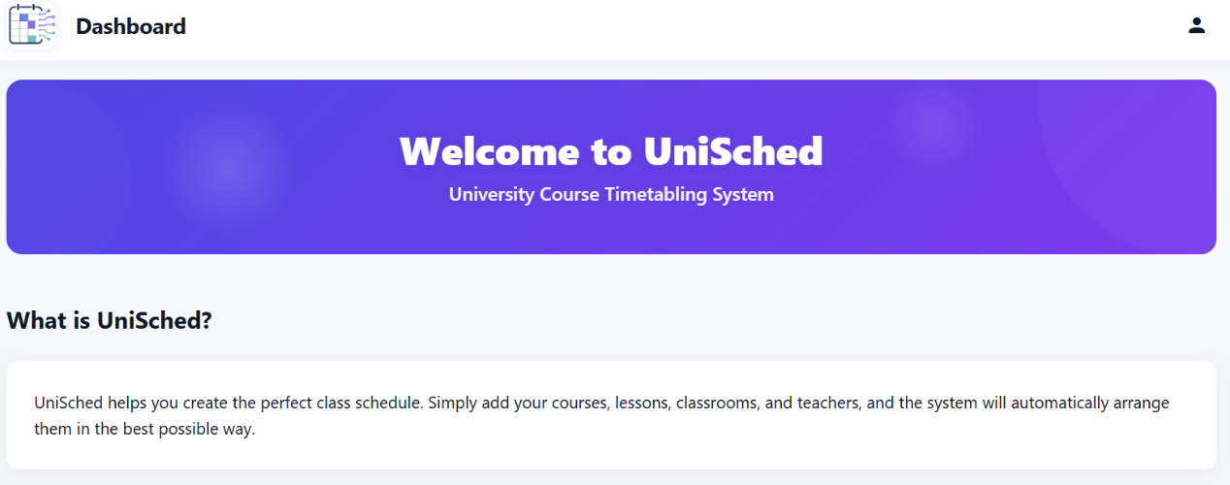

Sample Credentials:
- Email: unisched.system@gmail.com
- Password: 123456
Password Recovery: If you forget your password, click "Forgot Password" in the login screen. A reset link will be sent to your email (check your Spam/Junk folder if necessary).
User Roles
There are two types of users in the system:
- Standard User (User): Can input data and generate timetables.
- Administrator (Admin): Has extended permissions, including managing other users (adding, deleting, and changing permissions). Note: After logging in with the primary Admin account, you can create new users via the Settings page.

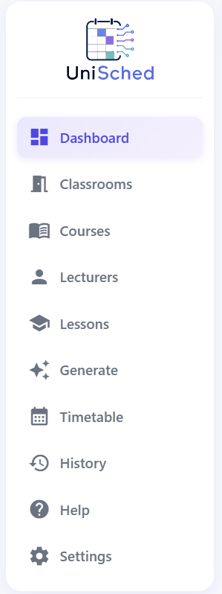
2. Navigation
On the left side of the screen, you will find the main navigation sidebar:
- Dashboard: General information and quick access to key actions (including downloading Excel templates). Clicking the system logo from any page returns you here.
- Classrooms: Manage campus classroom data.
- Courses: Manage the academic courses being taught.
- Lessons: Manage the actual lesson instances that need to be scheduled.
- Lecturers: Manage lecturer data, availability, and scheduling preferences.
- Generate: Configure constraints and run the scheduling algorithm.
- Timetable: View the schedule generated.
- History: View and manage previously saved timetables.
- Settings: Password change, scheduling settings, and user management settings (Admins only).
- Help: Additional information and guidance on using the system.

3. Core Workflow
The system already includes preconfigured data and settings, allowing timetable generation immediately after login. The following steps are mainly intended for users who want to modify existing data, upload new information, or configure the system differently.
To successfully generate a timetable with custom data, enter the information in the following order.
Step 1: Manage Clusters (Semesters)
Before entering any data, you must define the Clusters and Semesters in the system (e.g., Semester 1, Semester 2, Science Cluster, Labs Cluster, etc.).
- Go to the Settings page.
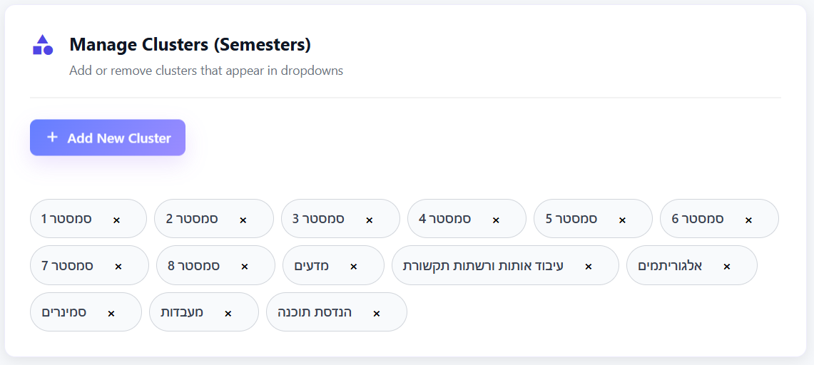
- Under Manage Clusters (Semesters), add the relevant clusters.
Important Note: The first 8 clusters created in the system are treated as regular semester clusters. Any cluster added after the first 8 will automatically be considered an elective course cluster.
Critical Note: If you try to add a Course or Lesson and cannot find the desired Cluster in the dropdown list, you must go back to Settings and add it first.

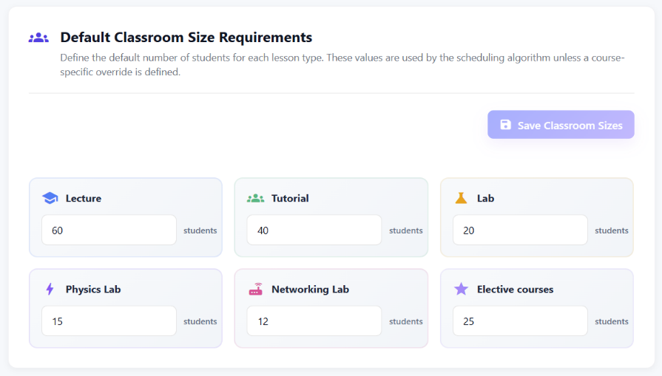
Step 2: Default Classroom Size Requirements
Before running the scheduling process, you must define the default number of students for each lesson type in the system. These values are used by the scheduling algorithm unless a course-specific override is defined.
- Go to the Settings page.
- Under Default Classroom Size Requirement, enter the default number of students for each lesson type.
- After editing the values, click the Save button to apply the changes.

Step 3: Define Global System Constraints
Before generating the schedule, you must define time slots in which teaching is completely prohibited for all lessons (for example, Active Breaks). The scheduling algorithm will not assign any lessons to the blocked slots.
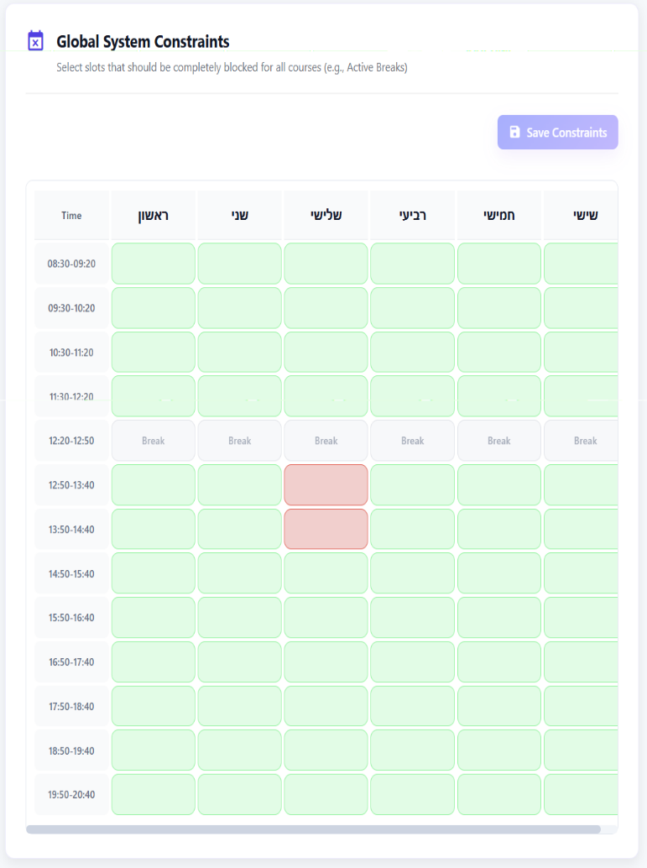
- Go to the Settings page.
- Under Global System Constraints, select the slots that should be blocked for all courses.
- Click on a slot to toggle its status:
- Red = Teaching is not allowed
- Green = Teaching is allowed
- After updating the constraints, click the Save button to apply the changes.

Step 4: Data Entry (General)
In the Classrooms, Courses, Lecturers, and Lessons pages, you can enter data in two ways:
- Bulk Upload (Excel): Download the Excel template from the Dashboard, fill it out, and upload it.
- Warning: Uploading an Excel file will completely overwrite and delete all existing data on that specific page (the system will warn you before proceeding).
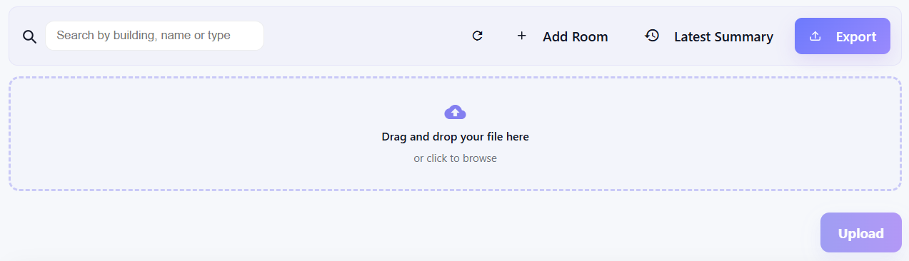
- After uploading, the system provides a detailed summary report showing which rows were successful and which failed (including the reason for failure). If you want to view the summary again later, click the Latest Summary button to reopen the report window.


- Manual Entry: Click the "Add" button (e.g., Add Course) and fill out the fields in the pop-up window.

Additional Actions on Each Page:
- Search & Filter: Use the search box at the top left to quickly filter the list. In addition, you can filter the data using the filter options located above the table, allowing you to narrow results by different values.
- Export to Excel: Click the Export button to download all current data on the page to an Excel file.
- Edit & Delete: Use the pencil icon to edit or the trash icon to delete a single entry. For bulk deletion, select the checkboxes of the desired items and click Delete selected at the bottom of the page. All deletions require confirmation.

4. Managing Entities
Classrooms:
- In the Classrooms page, click on the Add Room button to fill in classroom details.
- Note: In the "Room Name" field, include the building name (e.g., P101). Select the classroom type from the provided list.
Courses:
- In the Courses page, click on Add Course and enter course details, including Course Code, Course Name, Semester/Cluster, Lecture Hours, Tutorial Hours, Lab Hours, and Project Hours.
- When selecting a Semester/Cluster, the available options are taken from the values defined in the Settings page under Manage Clusters.
- Credit Calculation: The system automatically calculates credits based on the hours entered. To override this and enter credits manually, click the pencil icon next to the field and confirm the prompt.
- Prerequisites: This field is optional. If there are multiple prerequisites, enter the course code and click the small "+" icon to add it.
- Default classroom size requirements for Lecture, Tutorial, and Lab sessions are automatically loaded based on the values defined in the Settings page under Default Classroom Size Requirements. To override these values and enter custom sizes manually, click the pencil icon next to the field and confirm the prompt.

Lecturers:
- In the Lecturers, click on Add lecturer and enter the lecturers' names. Note: The system does not allow two lecturers with the exact same name.
- Managing Lecturer Availability:
- Select a lecturer from the list. The availability grid will appear on the right.
- Click the slots in the grid to set preferences. Each click cycles the slot through the available states: Green → Orange → Red → Green.
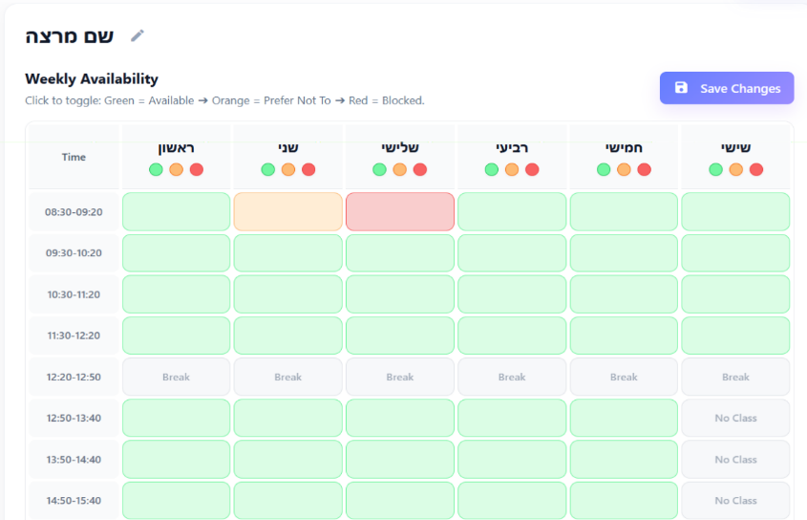
- Green: Available to teach.
- Orange: Prefers not to teach.
- Red: Cannot teach at all.
- To change the lecturer’s name after it has been added, click the pencil icon located to the right of the name.

- Quick Action: Click the colored circles (Green/Orange/Red) at the top of each day to change all slots for that day to the selected color.
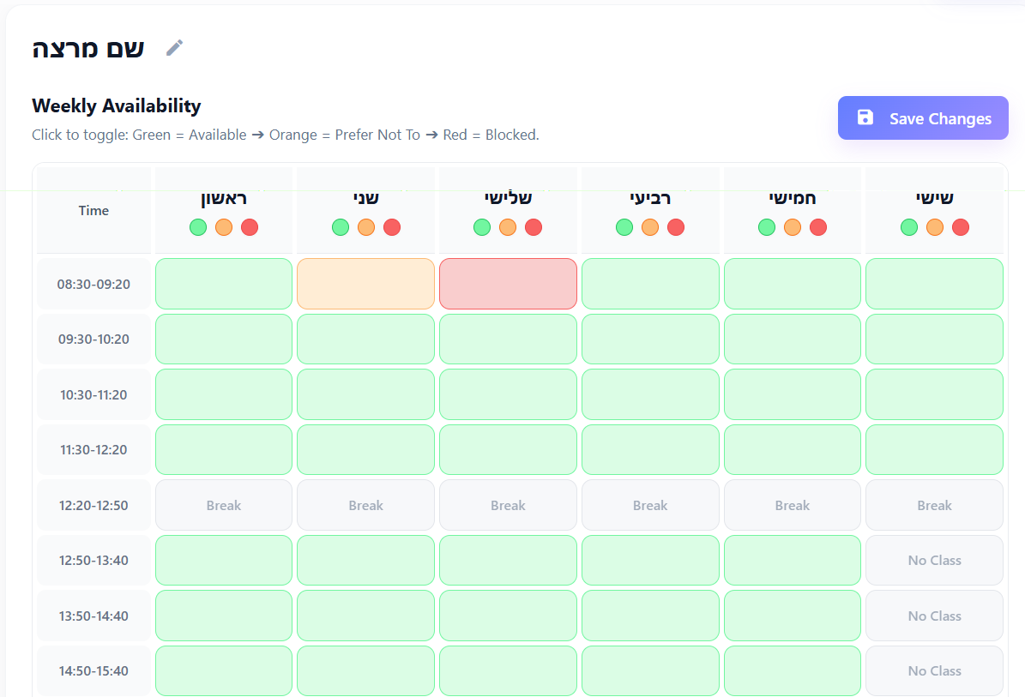
- Critical: You must click the Save Changes button to apply the updates. Otherwise, preferences will not be saved!
- Lessons:
- This page connects all previous data. All fields are mandatory.
- Data Dependency: The dropdown menus (Clusters, Courses, Lecturers) only display data previously entered in the system. Available "Lesson Types" for a course are derived from its definition on the Courses page.
- When selecting a Cluster, the list is based on the values defined in the Settings page under Manage Clusters.
- When selecting a Course, the list is based on the courses previously entered in the Courses page.
- When selecting a Lecturer, the list is based on the lecturers previously added to the system.
- Automatic Splitting: The system does not allow single lesson blocks longer than 3 hours. If a 4-hour lesson is entered, it will be automatically split into two identical 2-hour blocks.

5. Generating a Timetable (Generate)
This page is where you define the rules for the AI algorithm. Next to each element, there is a question mark icon, which provides additional information when you hover over it, explaining the specific setting.
- Select Semester: Choose the semester you want to generate for.
- Manual Assignments: You can "lock" specific lessons into a day, time, and room. The algorithm will treat these as fixed.
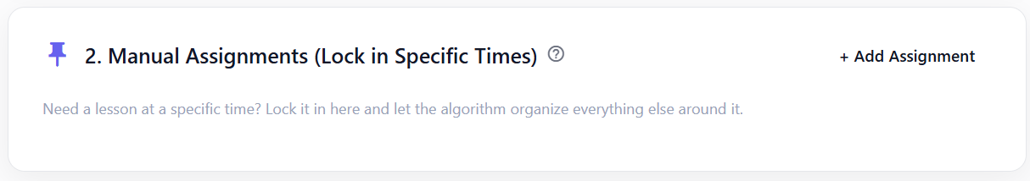
Click Add Assignment to open a window. Fill in all fields: select Cluster, then Course, then the specific Lesson (based on the Lessons page). Next, choose a Time Slot and Classroom. Note: the system does not validate this assignment (e.g., class size or lesson type), so make sure the details are correct before saving.


- Hard Courses: Select courses that are considered demanding. The system will prioritize scheduling their lectures in the early morning.

- English Courses (Friday / Afternoon Preference) – Select English/Hebrew courses that you want to give priority and allow scheduling on Fridays and in the afternoon. Note that if English courses already exist for the selected semester at the top of the page, the system will automatically include them.



- Virtual Courses (No Classroom Needed) – Select virtual courses that do not require a classroom. The options are based on the existing lessons in the system for the selected semester.


- Soft Constraint Weights: Guide the algorithm on your priorities. Weights range from 0 (Ignore) to 10 (Highest Priority).
- Note: Setting all weights to 10 will not yield the best results; careful prioritization is key.
- These are the constraints used by the AI scheduling algorithm, and they are divided into categories based on their purpose and impact.
Course Scheduling:
- Core Courses in the Morning – Prioritizes mandatory subjects for morning slots.
- Later Slots for Electives – Pushes elective/enrichment courses to the afternoon or evening.
- Prevent Component Overlap – Prevents scheduling a lecture and tutorial of the same course on the same day. Priority is given to lectures, but the system also attempts to separate tutorials where possible.
- English Course Optimal Timing – Schedules English courses in traditional slots (Friday morning or mid-week afternoon).
Room & Building:
- Optimize Classroom Capacity – Prevents using large rooms for small groups.
- Elective Room Grouping – Schedules different components of elective courses (e.g., lecture and tutorial) in the same classroom.
- Avoid Building P – Avoids scheduling in Building P unless absolutely necessary.
- Campus Load Balancing – Prefers keeping fewer than 20 concurrent classes per time slot to reduce system load and congestion.
Lecturer Constraints:
- Compact Staff Schedule – Minimizes gaps (“windows”) and long waiting times for lecturers.
- Lecturer Preferences – Respects lecturers’ requests to avoid teaching during Orange (unpreferred) time slots.
Student Experience:
- Morning Peak Performance – Schedules difficult (“Hard Courses”) during early morning hours.
- Avoid Late Hours & Fridays – Minimizes late-night slots and Friday classes (except English courses).
- Cluster Overlap Avoidance (Critical) – Prevents overlapping lessons within the same semester/cluster so students can attend all their classes.
- Minimize Student Windows – Reduces gaps (“windows”) in students’ schedules.
- Running the Algorithm: Click the button at the bottom of the page. The process may take some time as the system analyzes thousands of possibilities. If no solution is found that meets the "Hard Constraints," the system will notify you. Upon successful completion, the system will automatically redirect you to the Timetable page to view the result.

6. Viewing & Managing Schedules
Timetable:
- The generated schedule is displayed here.
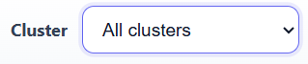
- Filter: You can filter the view by specific Clusters (e.g., viewing only Semester 1).
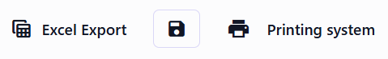
- Save & Print: Use the provided buttons to print the schedule, export it to Excel (a structured file organized by clusters for easy viewing), or save it to the database (you will be prompted to name the save).


- In the scheduling screen, you can manually delete a specific assignment. If the assignment is saved in the system, the saved version will also be updated accordingly.
History:
- Displays a list of all the timetables saved.
- You can edit the name of a saved schedule or delete it.
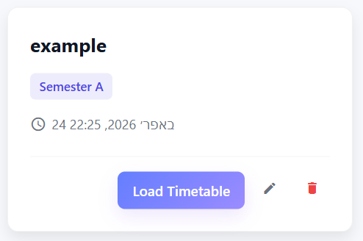
- Click Load Timetable to open a saved schedule back in the Timetable page for review.

- Dashboard & Settings & Support
Dashboard:
The Dashboard page contains basic usage information and serves as the system's main entry point. It includes:
- Import Information - Clicking this opens a window where you select the type of data to upload (e.g., lecturers), and the system will direct it to the appropriate section.
- Export Information - Exports the existing data for the selected page, similar to the export function available on other pages.
- Get Templates - Provides data upload templates for the system, including examples.
- Generate Timetable - A shortcut to the timetable generation page.
- View History - A shortcut to the history page.
Help:
This page contains further information and tutorials on system features.
Settings:
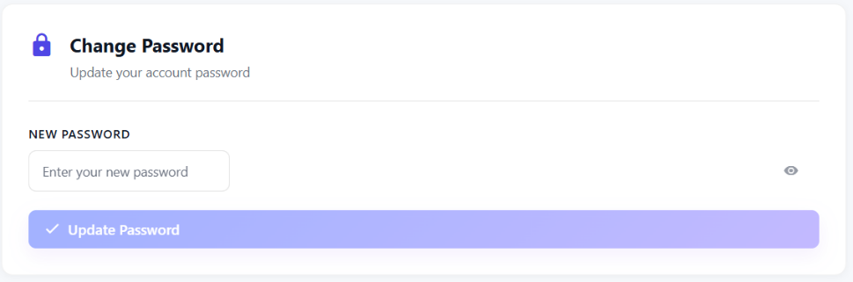
- Change the current user's password.

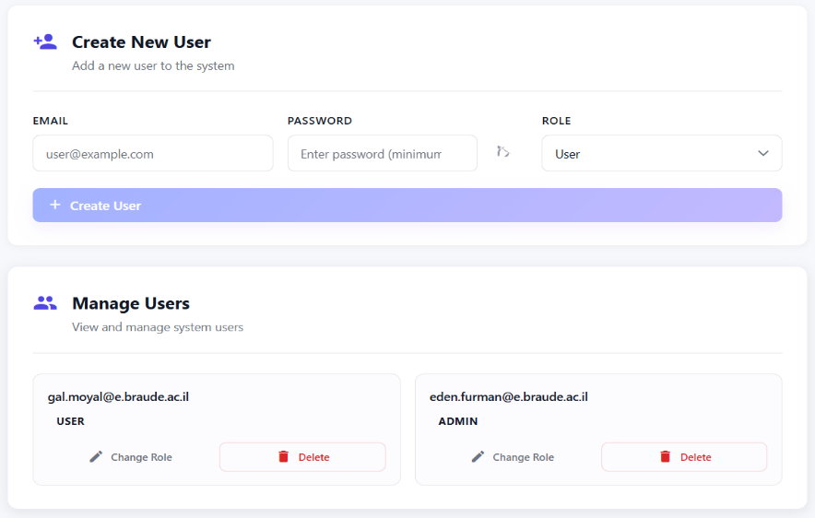
- User Management (Admins Only): Add new users, view the user list, delete users, or change their roles (User/Admin).
- Manage Clusters: As mentioned, use the bottom section to manage academic clusters.
- Default Classroom Size Requirements – as previously explained
- Global System Constraints – as previously explained

9. Excel Templates
The system provides Excel templates for bulk data upload.
Downloading Templates
- Go to the Dashboard page.
- Click Get Templates.
- Select the desired template type.
Available templates:
- Lecturers
- Courses
- Lessons
- Classrooms
Lecturers Template:
Columns:
Name | Hard Block Day | Hard Block Hour | Prefer Not Day | Prefer Not Hour
- Name - Lecturer name.
- Hard Block Day / Hour - Time slots in which the lecturer cannot teach.
- Prefer Not Day / Hour - Time slots the lecturer prefers to avoid teaching.
Days are represented by numbers: 1 = Sunday … 6 = Friday
Hours are also represented numerically according to the system’s time slots.
Example:
If a lecturer cannot teach on Sunday at the first time slot (08:30-09:30):
- Hard Block Day = 1
- Hard Block Hour = 1

Courses Template:
Columns:
Course Code | Course Name | Prerequisites / Conditions | Lecture Hours | Tutorial Hours | Lab Hours | Project Hours | Credits | Cluster Name | Lecture Number Students | Tutorial Number Students | Lab Number Students
- Course Code – Unique course identifier.
- Course Name – Course name.
- Prerequisites / Conditions – Optional prerequisite courses.
- Lecture / Tutorial / Lab / Project Hours – Weekly teaching hours for each lesson type.
- Credits– Course credits.
- Cluster Name – Must match an existing cluster defined in Settings.
- Lecture / Tutorial / Lab Number Students – Classroom size requirements.
If classroom size values are empty, the system uses the default values defined in Settings.
For elective courses, only the Lecture Number Students value is used.

Lessons Template:
Columns:
Course Number | Course Name | Type | Lecturer | Semester | Department | Hours
- Course Number / Course Name – Must match existing courses in the system.
- Type– Lesson type in Hebrew:
  - הרצאה
  - תרגול
  - מעבדה
- Lecturer – Must match an existing lecturer in the system.
- Semester – סמסטר א / סמסטר ב
The following columns are optional and mainly included for compatibility with existing institutional files:

- Staff / ממח / עמית
- Department
- Hours

Classrooms Template:
Columns:
Building | Classroom | Capacity | Type
- Building – Building name.
- Classroom – Classroom number/name. This should include the building identifier as part of the classroom name (for example: M100).
- Capacity – Maximum number of students.
- Type – Classroom type:
  - Normal
  - Laboratory
  - Auditorium
  - Networking Lab
  - Physics Lab

Important Notes
- Uploaded files must follow the exact template structure.
- Uploading a new Excel file replaces all existing data for that section.
- If referenced data does not exist in the system (such as clusters or lecturers), the upload may fail.

11.2. Maintenance manual
1. Project Repository
The project source code is available in the following GitHub repository:
https://github.com/GalMoyal111/course-scheduling-system.git
A future maintainer should download or clone the repository before making changes to the system. It is recommended to work on the latest version of the project and to keep track of changes using Git.
2. Required Tools
Before running or maintaining the system locally, make sure that the following tools are installed:
- Java
- Maven
- Git
3. Excel Files
The system supports data import using Excel files. These files are used to upload large amounts of data into the system in an organized way.
The relevant Excel data are included with the project and should be used as required by the system.
The main Excel files are:
- Classrooms file
- Courses file
- Lecturers file
- Lessons file
Each file has a specific structure that must be kept exactly as defined in the template. Changing column names, removing columns, or changing the expected data format may cause the upload process to fail.
- Running the System Locally
The system can be run locally for development, testing, or maintenance purposes. Before running the system, make sure that all required tools listed above are installed.
The frontend and backend must both be running in order to use the full system locally.

- Cloud Deployment
The system is deployed in the cloud so that users can access it through an external link without running it locally.
System Part | Deployment Platform
Frontend | Vercel
Backend | Render
Database | Firebase Firestore

Because the backend is deployed on a free cloud service, the server may go into sleep mode after some time without use. As a result, the first login or the first request to the system may take longer than usual. If the system does not load immediately, wait a short time and try again.
After making changes to the code, the maintainer should make sure that the deployed version still works correctly. It is recommended to check the following actions after deployment:
- Login to the system.
- Load data from the database.
- Upload an Excel file.
- Generate a timetable.
- View the generated timetable.
- Save the timetable.
- Load a saved timetable from the History page.
- Export the timetable to Excel.

11.3. System Usability Scale (SUS) Questionnaire
שאלון SUS למערכת UniSched

 | שאלות | מסכים בהחלט |  |  |  | לא מסכים כלל
 |  | 5 | 4 | 3 | 2 | 1
1 | נראה לי שהייתי מעוניין/ מעוניינת להשתמש במערכת מסוג זה לעיתים קרובות | v
2 | לדעתי המערכת מורכבת מדי שלא לצורך |  |  |  |  | v
3 | מצאתי את המערכת נוחה לשימוש | v
4 | נראה לי שאזדקק לעזרתו של איש טכני, כדי שאוכל להשתמש במערכת |  | v
5 | נראה לי שהפונקציות השונות של המערכת שולבו היטב ביחד | v
6 | נתקלתי במקרים רבים של חוסר עקביות לאורך השימוש במערכת |  |  |  | v
7 | נראה לי שרוב האנשים יכולים ללמוד להשתמש במערכת במהירות | v
8 | לדעתי המערכת הינה מסורבלת לשימוש |  |  |  | v
9 | הרגשתי מאוד בטוח/ בטוחה באופן השימוש במערכת |  | v
10 | הייתי צריך/ צריכה ללמוד הרבה לפני שהצלחתי להשתמש במערכת |  |  |  | v
- האם היו רגעים בתהליך בהם הרגשת תקוע/ תקועה? ואם כן, באילו חלקים ולמה? לא
- האם היו חלקים במערכת או בתהליך של השיבוץ שהם הרגישו מסובכים או לא מובנים? לא , הסברתם מאוד יפה , המערכת נגישה
- אם היית יכול/ יכולה לעשות שינוי כלשהו במערכת כדי שזה יענה יותר על הצרכים שלך מה היית מוסיף/ מוסיפה? – הייתי הופכת את המערכת ליותר ידידותית דהיינו, הייתי משנה ויזואלית את הכפתורים השונים, מוסיפה כפתור עזרה, דוחות ועוד.
נקודות לשיפור:
שיפור חזותי בלבד
נקודות לשימור:
המערכת מקסימה ומועילה הייתי שמחה אם היית יכולה לעבוד על יותר ממחלקה אחת

